Baca County 4-H Meat Judging
New Member Interest Form

Youth Name: ______________________________________ Town: ___________________
County: ____________________________ Age (on 12/31/18): _________ Grade: ________
Parent Name: ________________________________________________________________
Parent Email: _______________________________________ Phone: __________________
General Availability from February-May:
Please write all available meeting times below the days available and star your preferred time(s). Place a large “x” in the box on any days you are not available.
Times Available | Sunday | Monday | Tuesday | Wednesday | Thursday | Friday | Saturday

Are you willing to drive to Springfield for practices?
Yes No
Comments: _____________________________________________________________________________________

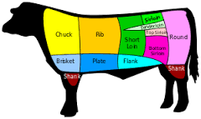
For more information or questions contact:
Tiana Garcia, Baca County Extension Agent
Tiana.Garcia@colostate.edu
Office: (719)523-6971
Cell/Text: (719)353-2137

